Report

Date | 1 May 2025
Team ID | Samrat, Mital, Chaitanya, Ratnadeep
Project Name | Global Malnutrition Trends: A Power BI Analysis (1983-2019)
Maximum Marks | 5 Marks
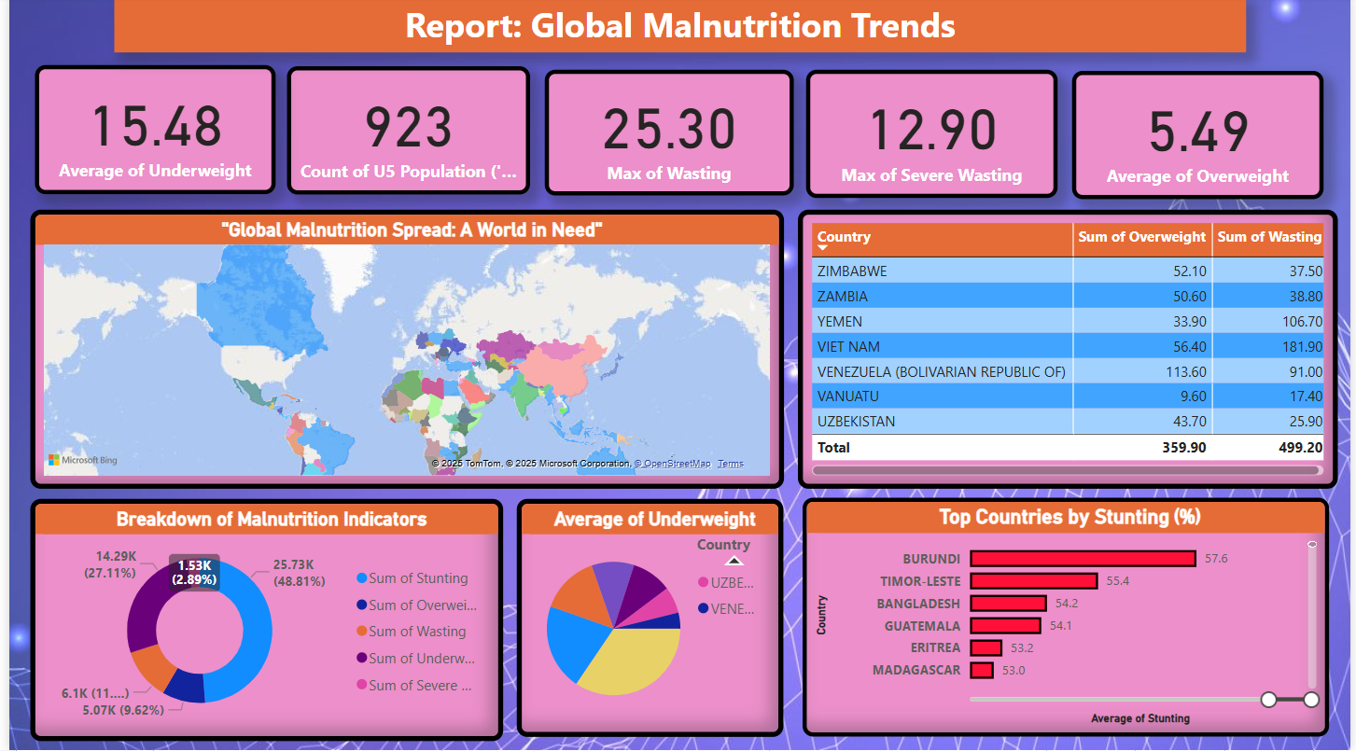

Observations from Power BI Report – “Global Malnutrition Trends”

1. Global Overview of Key Indicators
The dashboard highlights average malnutrition indicators globally:
- Average Underweight: 15.48%
- Average Overweight: 5.49%
- Maximum Wasting: 25.30%
- Maximum Severe Wasting: 12.90%
- The data also includes a total under-5 population count of 923, indicating the scale of data coverage.
These metrics provide an at-a-glance understanding of malnutrition severity and prevalence across multiple dimensions.

2. Geographical Disparities
The filled map visual titled “Global Malnutrition Spread: A World in Need” effectively shows malnutrition distributed globally.
Countries across Africa, South Asia, and parts of Latin America show higher rates of malnutrition indicators, while developed nations show lower prevalence but rising overweight concerns.

3. High-Risk Countries Identified
The table visualization highlights countries with both high overweight and wasting percentages:
- Vietnam and Venezuela show critical values across both extremes.
- Zambia and Yemen also reflect dangerously high rates of undernutrition.
These countries may require immediate intervention.

4. Distribution of Malnutrition Indicators
The donut chart illustrates the proportion of each malnutrition indicator:
- Stunting dominates with nearly 49% of total burden.
- Underweight and wasting are also substantial.
- Severe wasting and overweight represent a smaller share but are rising.
This breakdown emphasizes the need to prioritize stunting-focused programs.

5. Country-Level Breakdown
Visuals such as:
- Top Countries by Stunting %
- Average of Underweight by Country
...highlight Burundi, Timor-Leste, and Bangladesh as the most affected by stunting.
Countries like Uzbekistan and Venezuela show rising overweight percentages — a sign of the dual burden of malnutrition.

✅ Conclusion
This report offers a clear, visual, and data-driven understanding of the global malnutrition crisis. It helps identify high-burden regions, track indicator trends, and guide policy prioritization. Power BI's interactive visuals make it ideal for ongoing monitoring and stakeholder engagement.

